**UNIT-II**

**UNIT II:** Renewable Energy sources that can be used in Green Buildings – Conventional and Non Conventional Energy, Solar energy, Passive Solar Heating, Passive Solar collection, Wind and other renewables. A passive solar strategy, Photovoltaics, Rainwater Harvesting Climate and Energy, Macro and Microclimate. Indian Examples.

**RENEWABLE ENERGY SOURCES USED IN GREEN BUILDINGS:**

Green buildings aim to minimize their environmental impact by utilizing sustainable and renewable energy sources. Here are some renewable energy sources commonly used in green buildings:

**1. Solar Power:** Solar energy is a popular choice for green buildings. Photovoltaic (PV) panels are installed on rooftops or integrated into building materials to capture sunlight and convert it into electricity.

**2. Wind Power:** Wind turbines can be installed on-site or nearby to harness wind energy and generate electricity. They are particularly effective in locations with consistent and strong wind patterns.

**3. Geothermal Energy:** Geothermal systems utilize the stable temperature underground to provide heating, cooling, and hot water for buildings. Heat pumps extract geothermal energy from the earth and distribute it throughout the building.

**4. Biomass:** Biomass energy utilizes organic materials like wood pellets, agricultural waste, or dedicated energy crops to produce heat or electricity through combustion or conversion processes. Biomass boilers or combined heat and power (CHP) systems are common in green buildings.

**5. Hydropower:** Small-scale hydropower systems can be incorporated into buildings that are near a water source, such as rivers or streams. They use the flow of water to generate electricity through turbines.

**6. Tidal Energy:** In coastal areas with strong tidal currents, tidal energy converters can be used to generate electricity. These devices harness the kinetic energy of the tides and convert it into usable power.

**7. Micro Combined Heat and Power (CHP):** CHP systems simultaneously generate electricity and useful heat from a single fuel source, such as natural gas or biomass. They are efficient and can reduce overall energy consumption.

**8. Fuel Cells:** Fuel cells produce electricity through an electrochemical process, often using hydrogen as the fuel source. They can be used in green buildings to provide clean and reliable power, with water and heat as byproducts.

These renewable energy sources can be integrated into green buildings to reduce reliance on fossil fuels, minimize greenhouse gas emissions, and promote sustainable practices. The specific choice of energy sources depends on factors such as location, building design, energy requirements, and budget considerations.

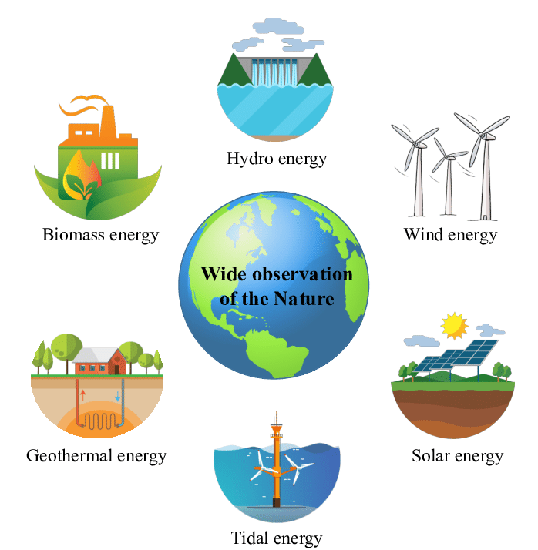

**CONVENTIONAL AND NON CONVENTIONAL ENERGY:**

Conventional and non-conventional energy are two broad categories of energy sources used to meet the world's energy demands. They differ in terms of their availability, environmental impact, and technological maturity. Let's explore each category:

**1. Conventional Energy:**

Conventional energy sources are those that have been traditionally used for many years and are well-established in the energy industry. They include:

**a. Fossil Fuels:** The most dominant conventional energy sources are fossil fuels, which include coal, oil, and natural gas. These resources are formed from the remains of ancient plants and animals, and their combustion releases energy in the form of heat and electricity. However, the combustion of fossil fuels also emits greenhouse gases and contributes to environmental issues like climate change and air pollution.

**b. Nuclear Energy:** Nuclear power is another conventional energy source. It involves the process of nuclear fission, where the nucleus of an atom is split, releasing a tremendous amount of energy. Nuclear power plants produce electricity, but they also generate radioactive waste, which requires careful management and disposal.

Advantages of Conventional Energy:

* Well-established infrastructure and technology.
* Reliable and continuous power supply.
* Can provide a large amount of energy for industrial and residential use.

Disadvantages of Conventional Energy:

* High greenhouse gas emissions (except nuclear) leading to climate change.
* Air pollution and health issues.
* Finite and non-renewable nature of fossil fuels.

**2. Non-Conventional Energy:**

Non-conventional energy sources, also known as renewable energy sources, are those that are replenished naturally and can be harnessed without depleting their resources. They are considered more environmentally friendly and sustainable compared to conventional sources. The main non-conventional energy sources are:

Solar Energy, Wind Energy, Hydroelectric Energy, Geothermal Energy, Biomass Energy e.t.c

Advantages of Non-Conventional Energy:

* Renewable and sustainable; will not deplete with use.
* Lower greenhouse gas emissions and reduced environmental impact.
* Diverse range of sources, suitable for different regions.

Disadvantages of Non-Conventional Energy:

* Initial setup costs can be high.
* Some sources, like solar and wind, are intermittent and dependent on weather conditions.
* Geographical and climatic limitations for certain sources.

In recent years, there has been a global shift towards increasing the share of non-conventional energy in the energy mix, driven by concerns over climate change, energy security, and environmental sustainability. The development and adoption of these renewable energy sources are crucial for a greener and more sustainable future.

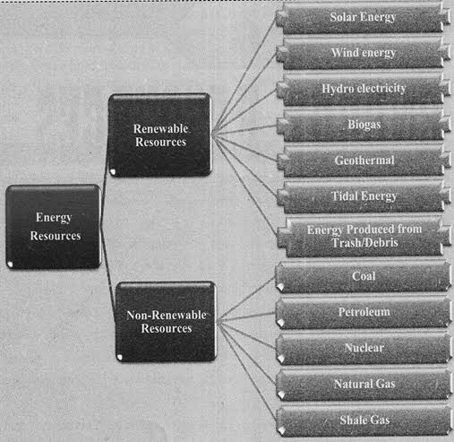

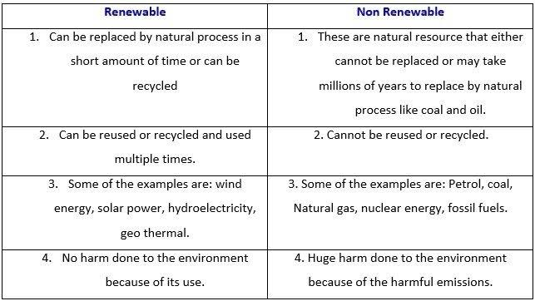

**SOLAR ENERGY:**

**Solar energy** is radiant light and heat from the Sun that is harnessed using a range of technologies such as solar power to generate electricity, solar thermal energy (including solar water heating), and solar architecture

* **Solar architecture** is an architectural approach that takes in account the Sun to harness clean and renewable solar power. It is related to the fields of optics, thermics, electronics and materials science.
* Both active and passive solar housing skills are involved in solar architecture.

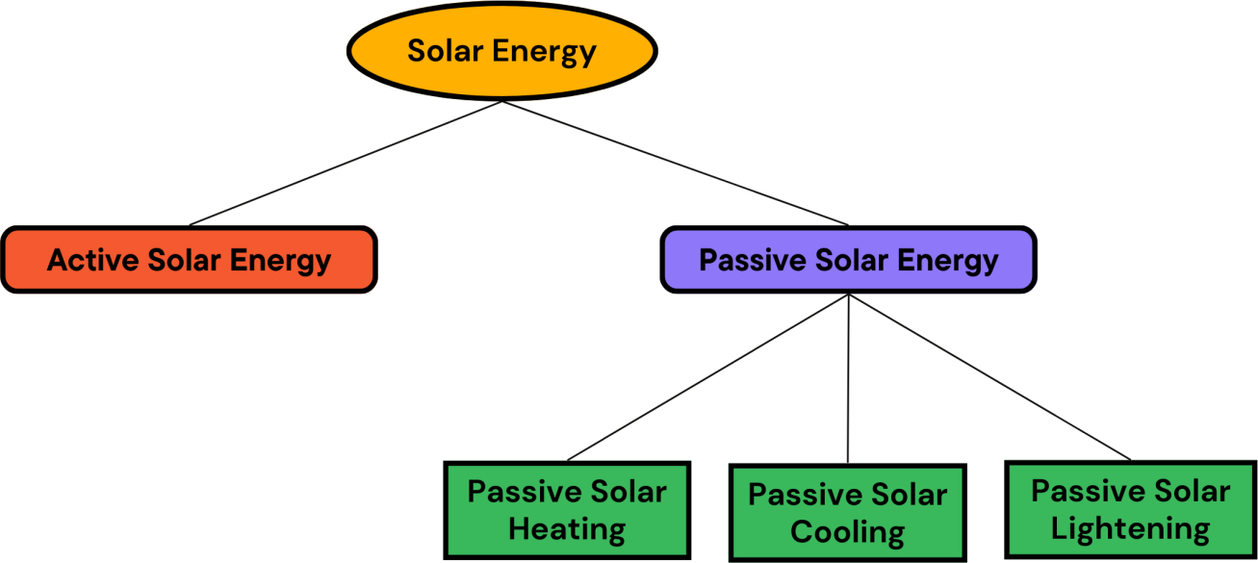

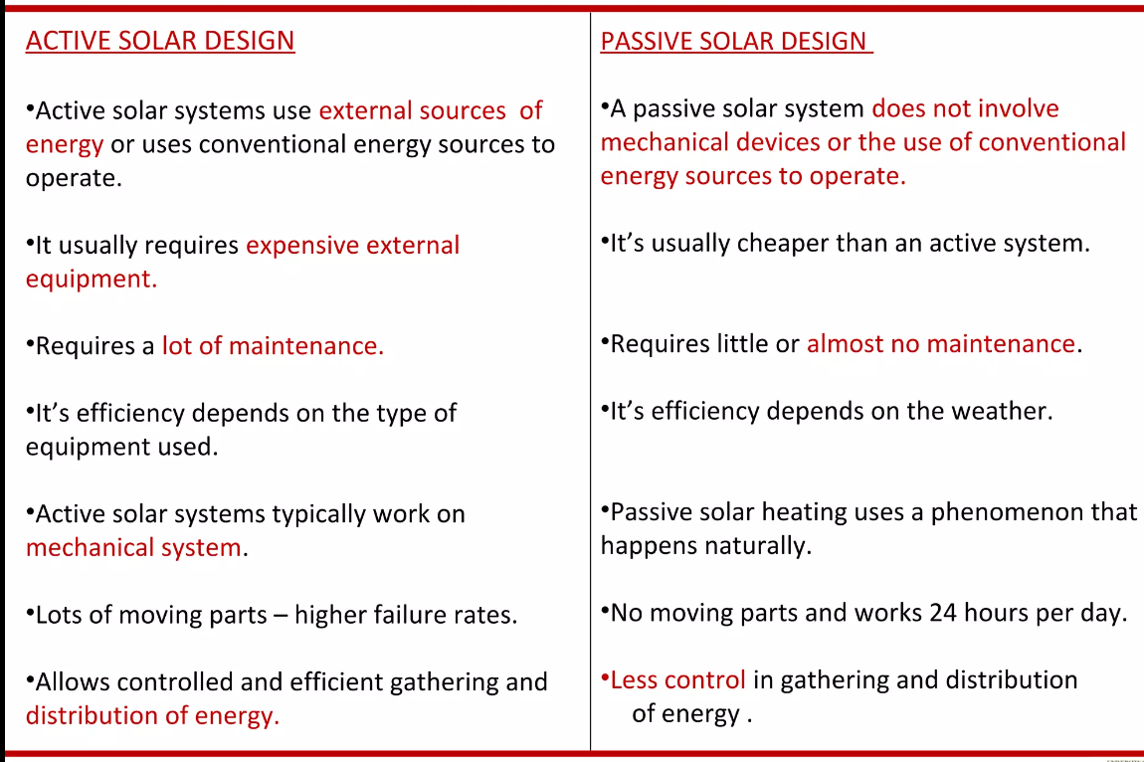

**PASSIVE SOLAR HEATING:**

* It is a design approach that utilizes the natural heat from the sun to provide indoor heating without the need for mechanical or electrical systems.
* It involves the strategic placement of building components and materials to capture, store, and distribute solar heat, making the building more energy-efficient and comfortable.

**Key Principles of Passive Solar Heating:**

1. **Solar Orientation:** Passive solar buildings are designed to maximize their south-facing exposure in the Northern Hemisphere (north-facing in the Southern Hemisphere) to receive the most sunlight throughout the day.
2. **Solar Collectors:** Large windows or glazing on the south-facing side act as solar collectors, allowing sunlight to enter the building and heat up the interior space.
3. **Thermal Mass:** High thermal mass materials, such as concrete, stone, or brick, are used inside the building to absorb and store the solar heat. These materials release the stored heat slowly, helping to regulate indoor temperatures.
4. **Insulation:** Adequate insulation is essential to prevent heat loss during colder periods, ensuring that the captured solar heat remains inside the building.
5. **Overhangs and Shading:** Properly designed overhangs or shading devices are used to block direct sunlight during warmer periods, preventing overheating and reducing cooling demands.
6. **Natural Ventilation:** Strategically placed windows and vents allow for natural cross-ventilation, facilitating heat distribution and promoting air circulation.

**Advantages of Passive Solar Heating:**

* ***Energy Efficiency:*** By harnessing free solar energy, passive solar heating reduces reliance on conventional heating systems and decreases energy consumption, leading to lower utility bills.
* ***Environmentally Friendly:*** Passive solar heating produces no greenhouse gas emissions or pollution, making it a sustainable and eco-friendly heating solution.
* ***Improved Comfort:*** Passive solar design provides a more even and comfortable indoor temperature, with reduced temperature fluctuations.
* ***Reliability:*** Passive solar heating systems have no moving parts and rely solely on the sun, making them more durable and requiring less maintenance.
* ***Long-term Savings:*** Although the initial construction costs may be slightly higher, passive solar buildings can lead to significant long-term savings due to reduced energy bills.

**Limitations and Considerations:**

* + ***Site and Climate:*** The effectiveness of passive solar heating depends on the building's location, orientation, and the local climate. Areas with less sunlight or colder temperatures may require supplementary heating.
  + ***Building Design:*** To fully benefit from passive solar heating, the building's design must incorporate the principles mentioned above. Retrofitting existing buildings can be more challenging and may have limitations.
  + ***Overheating:*** In some cases, passive solar buildings may be prone to overheating during hot summer months. Proper shading and ventilation strategies are crucial to avoid this issue.

**Methods of Passive Solar Heating:**

1. **Direct method**

* In the direct gain system, the living space collects, absorbs, and distributes the sun’s heat energy.
* The south-facing glass allows solar energy into the living space, where it directly and indirectly strikes thermal mass materials like [masonry walls](https://theconstructor.org/building/building-material/types-of-masonry-walling-materials/45598/) and floors.
* The thermal mass takes solar radiation during the daytime and emits heat energy at night into the living space. The direct gain uses around 60-75% of the sun’s heat that strikes the window.

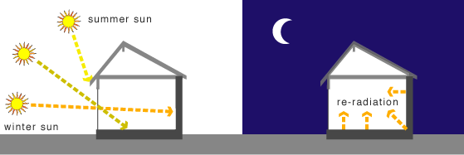

1. **Indirect Method**

* In this system, the thermal mass is between the sun and living space. Thermal mass absorbs heat energy from the sun and conducts it to the living space.
* Direct gain system utilizes 30-45% of sun’s heat energy that strikes the window. Three indirect gain solar passive heating techniques are available namely:  thermal storage wall systems (or Trombe wall), water wall, and roof pond.

**C) Trombe wall method**

* In daytime, Trombe walls facing the Sun have sunlight incident upon them. The wall absorbs and stores the heat coming from the direct solar radiation.
* Cool air from the building enters the air channel between the wall and the glazing through a vent that is present at the bottom of the wall. The cool air enters at the bottom, and is heated by the heat stored in the concrete wall.
* As this occurs, the warming air rises and is fed back into the building through a vent present at the top of the wall. Additionally, the wall itself heats the inside room slowly by radiating its heat into the room.
* At night, a Trombe wall functions differently. The vents at the top and bottom of the wall are closed to ensure that the now cool air in the channel between the glazing and the wall doesn't re-enter the home. Heat absorbed by the concrete wall is still able to maintain a comfortably warm internal space overnight.

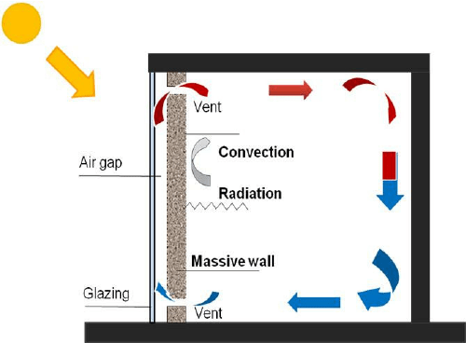

**d) Solar chimney**

* When the solar radiation hits the side of the chimney, the column of air inside the chimney is heated. If the ***top exterior vents*** of the chimney are ***closed***, the heated air is forced back into the living space.
* This provides a type of [convective air heating](https://energyeducation.ca/encyclopedia/Convection). As the air cools in the room it is pulled back into the solar chimney, heating once again

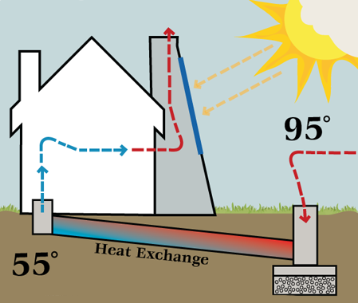

**e) Sunspaces/Scoria**

* It is an integration of direct gain and thermal storage concepts.
* Solar radiation admitted into the sunspace heats up the air, which by convection and conduction through the mass wall reaches the habitable space.
* It essentially consists of a greenhouse constructed on the south side of the building with a thick mass wall linking the two.

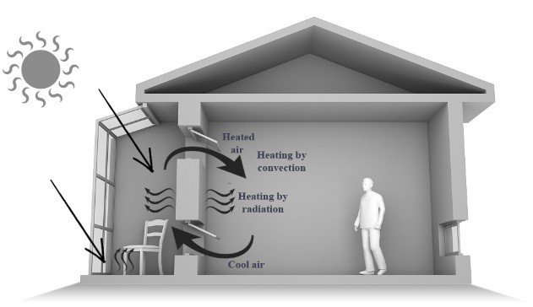

**<<<<< *Refer PPT for Passive Cooling and Lightening* *System* >>>>>**

**PASSIVE SOLAR COLLECTION:**

Passive solar collection refers to the utilization of natural processes and design elements to harness solar energy without the need for mechanical or electrical systems. It involves using the building's design, orientation, and materials to optimize solar heat gain during the winter months and minimize it during the summer, reducing the need for artificial heating and cooling.

Passive solar collection typically involves three main components:

1. ***Orientation****:* Proper orientation of a building is crucial for passive solar collection. The longest sides of the building should ideally face south (in the northern hemisphere) to maximize exposure to the sun's rays during the colder months. This allows the building to receive more direct sunlight, which can be absorbed and stored as thermal mass.

1. ***Solar Aperture:*** This is the part of the building that captures sunlight. It usually consists of south-facing windows, skylights, or other openings that allow sunlight to enter the structure.
2. ***Thermal Mass:*** Thermal mass refers to materials with high heat capacity, such as concrete, brick, or stone, that absorbs and store heat. These materials help regulate temperature by absorbing excess heat during the day and releasing it slowly at night, thus stabilizing indoor temperatures.
3. ***Insulation****:* Adequate insulation is important to prevent heat loss during colder periods and heat gain during warmer periods. Proper insulation reduces the need for active heating and cooling systems.
4. ***Distribution Mechanism:*** The captured solar energy is circulated throughout the building by natural convection, radiant heat transfer, or through fans or ducts. The design may include features like vents, fans, or trombe walls (mass walls with air channels) to distribute heat effectively.

By incorporating these elements into a building's design, passive solar collection can provide heating and cooling benefits. During winter, the sun's rays enter through the solar aperture and heat up the thermal mass, which then radiates warmth into the living spaces. In summer, shading devices or proper orientation can prevent excessive heat gain.

Passive solar collection is considered an energy-efficient and environmentally friendly approach to space heating and cooling, as it reduces reliance on fossil fuels and minimizes greenhouse gas emissions associated with traditional heating and cooling systems. It can be applied to residential homes, commercial buildings, and even larger structures like greenhouses and solar chimneys.

**WIND AND OTHER RENEWABLES:**

**1. WIND POWER ENERGY:**

Wind power energy, commonly referred to as wind energy, is a renewable energy source derived from the kinetic energy of moving air. It is harnessed using wind turbines, which convert the mechanical energy of the wind into electrical energy that can be used for various purposes, such as electricity generation for homes, businesses, and industries.

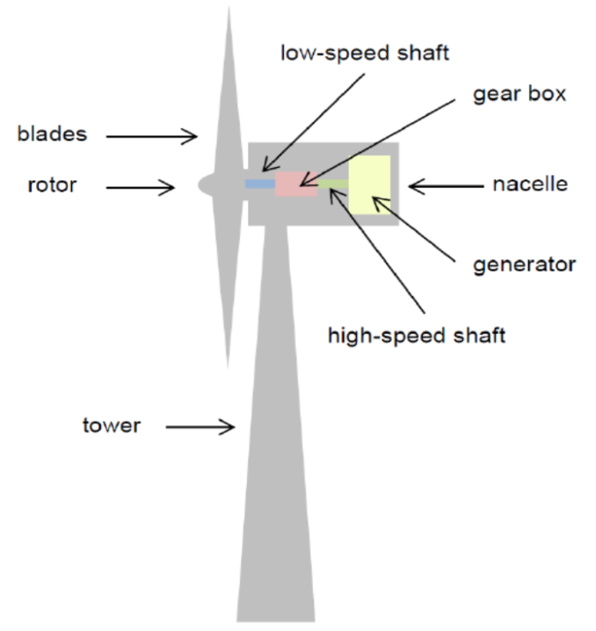 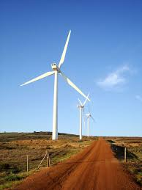

Here's how wind energy works:

**1. Wind Turbines:** Wind turbines are the primary technology used to capture wind energy. These structures consist of several key components:

* 1. ***Rotor* *Blades*:** Large, aerodynamically designed blades capture the kinetic energy of the wind.
  2. ***Rotor* *Hub*:** Central component that connects the rotor blades to the main shaft.
  3. ***Generator*:** Converts the rotational motion of the main shaft into electrical energy.
  4. ***Nacelle*:** It is the housing that contains the generator, gearbox, and other mechanical components.
  5. ***Tower:*** Supports the rotor and nacelle, elevating them to a height where stronger and more consistent winds are found.

**2. Wind Conversion:** When the wind blows, it causes the rotor blades to rotate. This rotational motion is transferred to the generator through the main shaft. Inside the generator, electromagnetic induction creates an electrical current, which is then collected and transmitted to the power grid for distribution.

**3. Wind Speed and Power Output:** The power output of a wind turbine is proportional to the cube of the wind speed. This means that even a small increase in wind speed can lead to a significant increase in power generation. Wind turbines are designed to start generating electricity at a certain minimum wind speed (cut-in speed) and to shut down at a higher wind speed (cut-out speed) to prevent damage.

**Advantages of Wind Energy:**

* + ***Renewable:*** Wind energy is a renewable resource, meaning it won't deplete as long as the Earth's atmosphere continues to have wind patterns.
  + ***Low Environmental Impact:*** Wind power has a relatively low environmental impact compared to fossil fuels, as it produces no greenhouse gas emissions during operation.
  + ***Reduced Water Usage:*** Wind turbines require very little water for their operation, unlike many conventional power plants.
  + ***Local Economic Benefits:*** Wind farms can provide economic benefits to local communities through job creation, land lease payments, and increased tax revenue.

**Challenges and Considerations:**

* + ***Intermittency:*** Wind energy generation is intermittent, as it depends on wind availability. Energy storage solutions and a diverse energy mix are often used to mitigate this challenge.
  + ***Visual and Noise Concerns:*** Some people have concerns about the visual impact and noise generated by wind turbines, particularly in densely populated areas.
  + ***Infrastructure and Permitting:*** Developing wind projects requires suitable infrastructure, transmission lines, and permits, which can involve regulatory challenges.

**2. HYDRO POWER ENERGY:**

Hydropower, also known as hydroelectric power, is a renewable energy source that harnesses the energy of flowing water to generate electricity. It is one of the oldest and most widely used forms of renewable energy, with a history dating back to ancient civilizations. Hydropower is derived from the potential and kinetic energy of water as it flows downstream due to gravity.

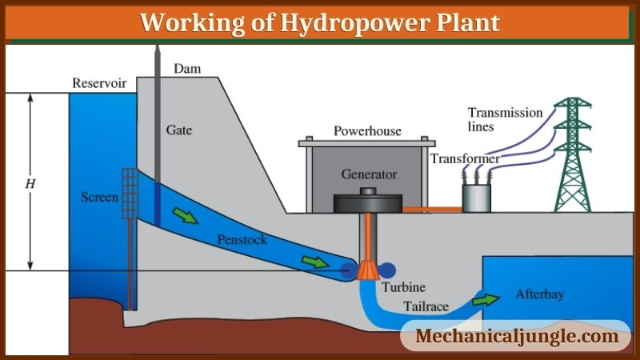

Here's how hydropower energy works:

* 1. **Dam and Reservoir:** One common method of hydropower generation involves building a dam on a river to create a reservoir or artificial lake. The dam controls the flow of water and creates a height difference (head) between the water surface behind the dam and the water level downstream.
  2. **Penstock:** The dammed water is released through a large pipe called a penstock. As the water flows downhill through the penstock, its potential energy is converted into kinetic energy, resulting in high-speed water flow.
  3. **Turbine:** At the bottom of the penstock, the high-speed water strikes the blades of a turbine. The turbine is connected to a generator, and the force of the water causes the turbine to rotate.
     1. **Generator:** The rotational motion of the turbine shaft is transferred to the generator, where it is converted into electrical energy using electromagnetic induction. The generator produces alternating current (AC) electricity.
  4. **Transmission:** The generated electricity is then transmitted through power lines to homes, businesses, and industries for various applications.

**Advantages of Hydropower:**

* + ***Renewable and Reliable:*** Hydropower is a renewable energy source, reliant on the natural water cycle, and provides a reliable source of electricity, as long as there's a steady supply of water.
  + ***Low Greenhouse Gas Emissions:*** Hydropower generates very low greenhouse gas emissions compared to fossil fuels, making it environmentally friendly.
  + ***Storage Capability:*** Reservoir-based hydropower provides a means of energy storage, as excess electricity can be used to pump water back into the reservoir during periods of low demand.

**Challenges and Considerations:**

* + ***Environmental Impact:*** Large dams can have significant environmental impacts, including habitat disruption, altered water flow, and potential displacement of communities.
  + ***Land and Infrastructure:*** Building dams and other infrastructure can require large amounts of land and have significant upfront costs.
  + ***Siltation and Sedimentation:*** Over time, reservoirs can accumulate sediment, which can reduce the reservoir's storage capacity and affect its efficiency.

**3. Geothermal Energy: (Geo=Earth & Thermal=Heat)**

Geothermal power energy harnesses the heat stored within the Earth's crust to generate electricity and provide heating and cooling for various applications. This renewable energy source relies on the natural heat produced by the Earth's internal processes, primarily from the decay of radioactive isotopes and the original heat from the Earth's formation. They can be used in 3 ways

1. **Direct Geothermal Energy:**

It can be accessed in areas where hot springs/geothermal reservoirs are near the surface of the Earth.

**Ex:** Hot Water, Cooking, Heating & cooling of houses, Agriculture, Aquaculture, Industrial Purpose e.t.c

1. **Geothermal Heat Pumps:**

It utilizes a series of underground pipes, an electric compressor and a heat exchanger to absorb and transfer heat.

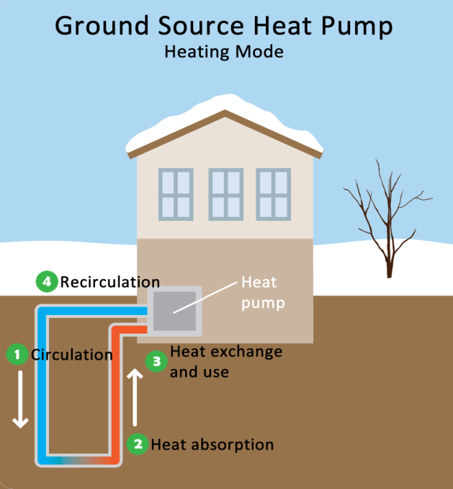 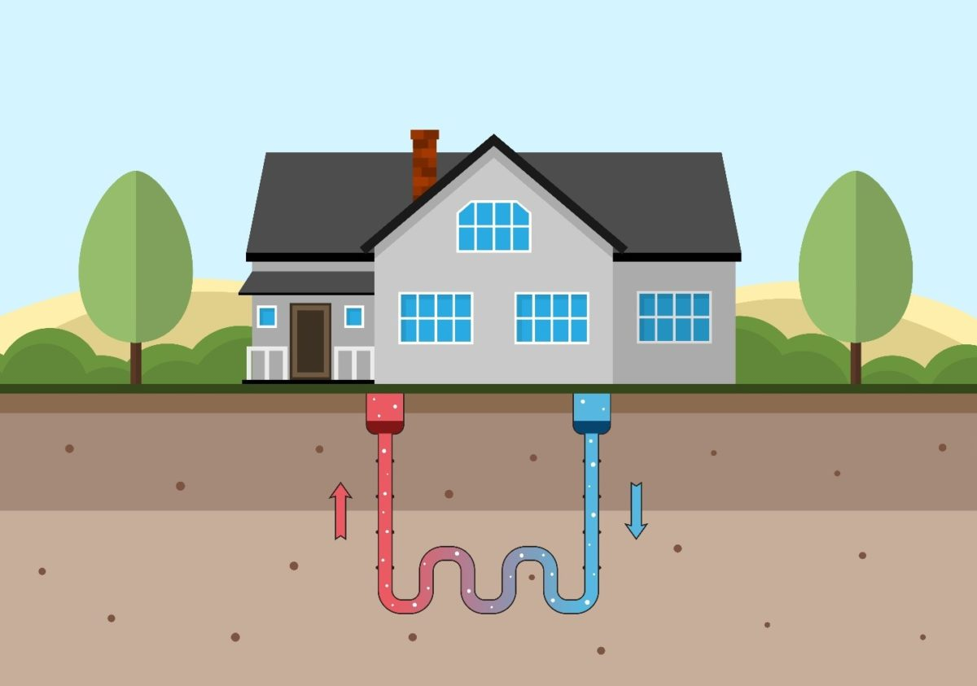

1. **Geothermal Power Plants:**

These are basically three types, i. Dry steam power plant (Steam temp >450 °F)

ii. Flash steam power plant (Water temp >350 °F)

iii. Binary cycle power plant (Water temp <350 °F)

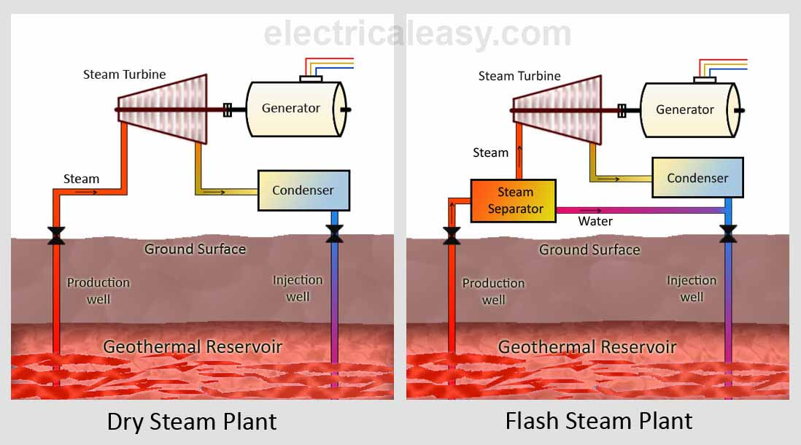

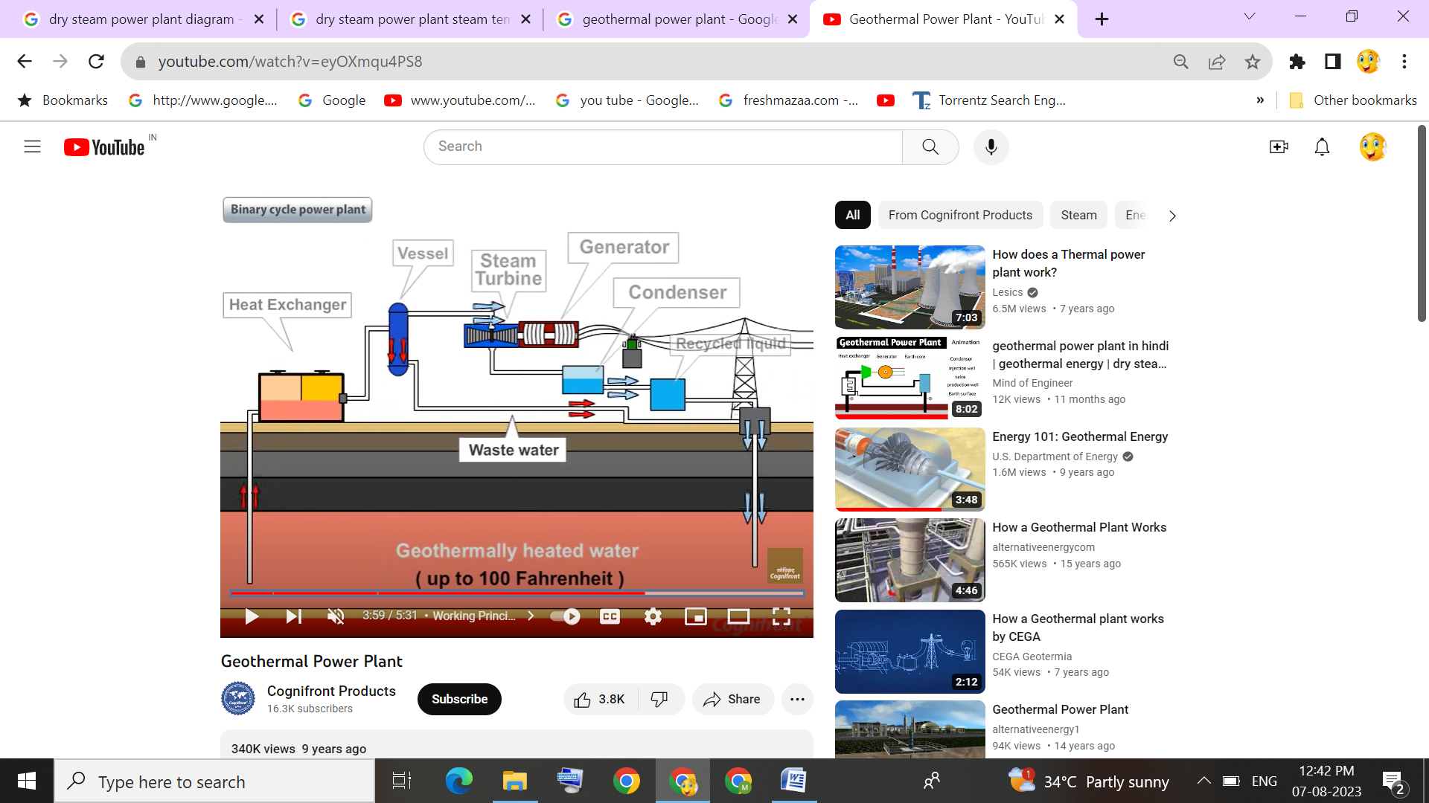

***Binary Cycle Power Plant***

Geothermal power plants are facilities that harness heat from the Earth's internal thermal energy to generate electricity. This type of power generation takes advantage of the heat stored beneath the Earth's surface, which is a result of the radioactive decay of minerals and the heat retained from the planet's formation.

There are several types of geothermal power plants, each with its own method of utilizing the Earth's heat:

* 1. ***Dry Steam Power Plants:*** These plants utilize high-pressure, high-temperature steam from underground geothermal reservoirs to directly turn turbines and generate electricity. The steam is extracted from the reservoir, separated from any liquid water, and used to drive turbines. After passing through the turbines, the steam is condensed back into water and injected back into the reservoir.
  2. ***Flash Steam Power Plants:*** These plants take high-pressure hot water from the reservoir and allow it to rapidly expand into a lower pressure environment, causing the water to "flash" into steam in a steam separator chamber. This steam is then used to drive turbines, similar to dry steam plants. The remaining water is re-injected into the reservoir.
  3. ***Binary Cycle Power Plants:*** In these plants, lower temperature geothermal resources are used to heat a secondary working fluid with a lower boiling point than water, such as isobutane or pentane in heat exchanger chamber. This working fluid vaporizes at a lower temperature in vessel and is used to turn turbines, which then generate electricity. The advantage of binary cycle plants is that they can utilize geothermal sources with temperatures as low as 100°C (212°F).

**Advantages of Geothermal Energy Power Plants:**

* + - ***Renewable and Sustainable:*** Geothermal energy is a renewable resource, as it is generated from the Earth's internal heat, which is essentially inexhaustible on human timescales.
    - ***Low Emissions:*** Geothermal power plants have relatively low greenhouse gas emissions compared to fossil fuel-based power plants, contributing to cleaner air and reduced carbon footprint.
    - ***Consistent Power Generation:*** Geothermal energy is available 24/7, providing a stable and consistent source of power, unlike some other renewable sources like solar or wind that depend on weather conditions.

**Disadvantages of Geothermal Energy Power Plants:**

* + - ***Location Specific:*** Geothermal power plants require specific geological conditions, such as access to hot rock layers or underground reservoirs, limiting their feasibility to certain regions.
    - ***High Initial Costs:*** The development and drilling of geothermal wells can incur high upfront costs, which may make it less economically viable in some cases.
    - ***Resource Depletion and Cooling:*** Prolonged or intensive use of geothermal reservoirs can lead to resource depletion and cooling, reducing the efficiency and lifespan of the plant.
    - ***Geological Risks:*** Drilling for geothermal energy can carry geological risks, including the potential for earthquakes or other ground-related disturbances.

**4. WAVE POWER ENERGY:**

Wave power energy, also known as wave energy, is another form of renewable energy that harnesses the energy from ocean waves to generate electricity. The working of wave power energy involves several steps:

**1. Wave Generation:** Ocean waves are generated by the wind as it blows across the surface of the water. The energy from the wind is transferred to the water, creating the characteristic up-and-down motion of waves. The size and strength of the waves depend on factors like wind speed, duration, and fetch (the distance over which the wind travels across the water).

**2. Wave Energy Conversion Devices:** Various types of devices are designed to capture the energy from the waves. These devices are typically installed offshore, where wave energy is strongest. There are several types of wave energy conversion devices, including point absorbers, oscillating water columns, attenuators, and overtopping devices.

1. ***Point Absorbers:*** These devices float on the water's surface and use the vertical motion of waves to drive a hydraulic piston or other mechanism. This motion is then converted into mechanical energy and, subsequently, into electricity using a generator.
2. ***Oscillating Water Columns*:** These systems consist of a partially submerged chamber open to the ocean. As waves enter the chamber, the air inside moves up and down, driving a turbine located above the water surface. The turbine's rotation generates electricity.
3. ***Attenuators:*** They are long, floating structures that move with the waves. They have multiple joints or hinges that bend and flex as waves pass through them. This motion is harnessed to drive hydraulic systems or generate electricity.
4. ***Overtopping Devices:*** Overtopping devices use the potential energy of waves that wash over the top of a structure (such as a seawall or a reservoir). The water is collected and funneled to a lower reservoir through turbines, generating electricity as it flows downward.

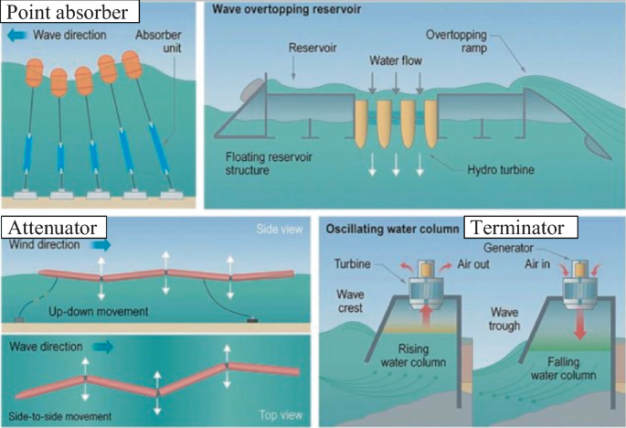

**3. Energy Conversion and Transmission:** Regardless of the specific device, the captured mechanical energy is converted into electricity using generators. The mechanical motion of the devices is translated into rotational motion, which drives the generator's rotor. This, in turn, induces an electromagnetic field that generates electrical current.

**4.** **Power Distribution:** The generated electricity is then transmitted through cables to an onshore substation, where the voltage may be adjusted and synchronized with the grid. From there, the electricity is integrated into the existing power grid for distribution to consumers.

* Advantages
  + Renewable
  + Environmentally friendly compared to fossil fuel energy
  + Variety of designs to use
  + Less energy dependence from foreign governments
* Disadvantages
  + Can affect the marine environment
  + May disturb private or commercial shipping
  + Dependent on wavelength for best operation
  + Visual/Noise issues
  + Poor performance in rough weather

**5. BIO FUEL ENERGY:**

Biofuels are renewable energy sources derived from organic materials, typically plant matter or animal waste. They can be used as alternatives to fossil fuels for transportation, heating, and electricity generation. Biofuels are considered renewable because the plants used to produce them can be regrown, absorbing carbon dioxide from the atmosphere during their growth, which helps offset the carbon emissions released when the biofuels are burned.

There are several types of biofuels:

**1. Bioethanol:** It is a type of alcohol made from fermenting sugars or starches found in crops like corn, sugarcane, wheat, and switchgrass. It's commonly used as a gasoline additive to reduce greenhouse gas emissions and increase octane levels. Flexible-fuel vehicles can use ethanol blends, such as E85 (85% ethanol and 15% gasoline).

**2. Biodiesel:** Biodiesel is made from vegetable oils, animal fats, or recycled cooking oils. It's used as a diesel fuel substitute or additive. Biodiesel can be blended with regular diesel fuel or used in its pure form, reducing emissions of sulfur, particulates, and greenhouse gases.

**3. Biogas:** Biogas is produced through anaerobic digestion of organic waste materials, such as agricultural residues, animal manure, and food scraps. It primarily consists of methane and carbon dioxide. Biogas can be used directly for heating or electricity generation, or it can be upgraded to natural gas quality and used as a vehicle fuel.

**4. Syngas (Synthetic Gas):** Syngas is produced by gasification, a process that converts biomass into a mixture of hydrogen and carbon monoxide. Syngas can be further processed to produce biofuels like synthetic diesel or synthetic natural gas.

 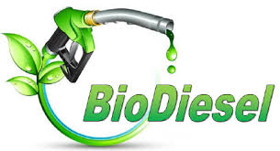

Biofuels offer several benefits:

* + ***Reduced Carbon Emissions:*** Biofuels release fewer carbon emissions than fossil fuels because the carbon dioxide they emit during combustion is balanced by the carbon dioxide absorbed by the plants during their growth.
  + ***Domestic Energy Source:*** Biofuels can reduce dependence on imported fossil fuels, promoting energy security and local economic development.
  + ***Waste Management:*** Biogas production utilizes organic waste that might otherwise contribute to landfills or emit methane, a potent greenhouse gas.
  + ***Compatibility with Existing Infrastructure:*** Biofuels can be used in existing engines and fuel distribution systems, requiring minimal modifications.

However, there are also challenges associated with biofuels:

* + ***Land Use Competition:*** Growing crops for biofuel production can compete with food crops and impact land use decisions.
  + ***Energy Intensity:*** The energy required to grow, harvest, and process the feedstock can sometimes offset the benefits of biofuels.
  + ***Indirect Land Use Change:*** The expansion of biofuel crops can lead to deforestation or conversion of natural habitats, potentially causing indirect increases in carbon emissions.
  + ***Technical and Economic Challenges:*** Developing cost-effective and efficient conversion technologies is crucial for widespread biofuel adoption.

**PASSIVE SOLAR STRATEGIES:**

Passive solar strategies are design principles and techniques used to optimize the utilization of natural sunlight and thermal energy in buildings. These strategies aim to maximize energy efficiency, minimize reliance on mechanical systems, and provide comfortable living or working environments. Some common passive solar strategies:

***1. Building Orientation:*** Properly orienting a building is crucial to take advantage of the sun's path throughout the day. In the northern hemisphere, south-facing windows receive the most sunlight. By orienting the longest side of the building toward the south, it allows for maximum solar exposure in winter while minimizing it during summer.

***2. Solar Apertures:*** Designing windows, skylights, or other openings on the south side of the building maximizes the collection of solar energy. These openings allow sunlight to enter the building, providing natural lighting and passive heating.

***3. Shading and Overhangs:*** Incorporating shading devices such as roof overhangs, awnings, or louvers helps to block direct sunlight during summer months, preventing overheating. These devices are designed to allow sunlight in during winter when the angle of the sun is lower, providing warmth.

***4. Thermal Mass:*** Utilizing materials with high thermal mass, such as concrete, brick, or stone, within the building's structure helps absorb and store heat. The thermal mass can absorb heat during the day and release it slowly at night, stabilizing indoor temperatures and reducing temperature fluctuations.

***5. Natural Ventilation:*** Designing the building to facilitate natural airflow can help regulate temperature and improve indoor air quality. Strategic placement of windows and vents promotes cross-ventilation, allowing cool breezes & warm air to exit naturally.

***6. Insulation and Air Sealing:*** Proper insulation and air sealing are essential to minimize heat loss during winter and heat gain during summer. Insulating materials and sealing gaps and cracks help create a more energy-efficient building envelope.

7. Passive Solar Heating Systems: Supplementing passive solar strategies with active solar heating systems, such as solar water heaters or solar air heaters, can further enhance the heating capabilities of a building.

Passive solar strategies can be applied to various types of buildings, including homes, offices, schools, and other structures. By utilizing these design principles, buildings can benefit from reduced energy consumption, lower operating costs, improved thermal comfort, and decreased environmental impact.

**PHOTOVOLTAICS:**

A photovoltaic (PV) cell, also known as a solar cell, is an electronic device that converts sunlight directly into electricity through a process called the photovoltaic effect. This technology plays a crucial role in generating renewable energy from sunlight. PV cells are the building blocks of solar panels, which are used to capture and convert solar energy into usable electricity.

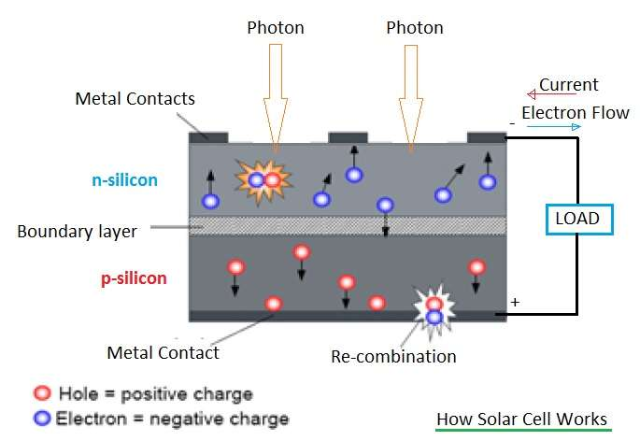

Here's how a photovoltaic cell works:

* 1. ***Photon Absorption:*** When sunlight (photons) hits the surface of the PV cell, it interacts with the semiconductor material that makes up the cell. Most commonly, this semiconductor material is made of silicon.
  2. ***Generation of Electron-Hole Pairs:*** The energy from the absorbed photons excites the electrons in the semiconductor material, causing them to break free from their atoms. This creates "electron-hole pairs" – the electron becomes mobile and carries a negative charge, while the hole left behind carries a positive charge.
  3. ***Electron Flow:*** Due to internal structure of the cell, mobile electrons move towards the front surface of the cell, while the positively charged holes move towards the rear surface. This separation of charges creates an electric field within the cell.
  4. ***Collection of Electrons:*** The electric field drives the free electrons towards the front surface of the cell, which is usually coated with a conductive metal layer. This metal layer collects the electrons, creating an electric current.
  5. ***External Circuit:*** The collected electrons flow through an external circuit, such as wires connected to the cell, to reach the other side of the cell where the holes are collected. This flow of electrons through the circuit is what we recognize as electric current. The electric current generated by the PV cell can be used to power electrical devices, charge batteries, or be fed into the electrical grid for broader use.

***Types of Solar PV Generating System:***

When photovoltaic modules are exposed to sunlight, they generate electricity in d.c. waveform. PV power generating systems can broadly be classified into two

1. On-Grid Solar Energy System (Grid connected solar PV system)
2. Off-Grid Solar Energy System (Stand alone solar PV system)

**i. On-Grid Solar Energy System:**

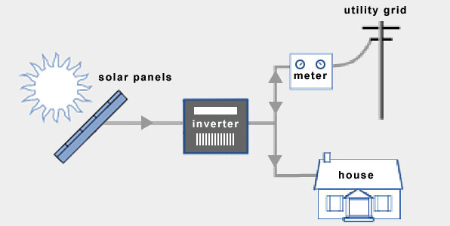

An on-grid solar energy system, also known as a grid-tied solar system or grid-connected solar system, is a type of solar power installation that is connected to the electrical grid. In this setup, the solar panels generate electricity from sunlight, and the generated electricity can be used to power your home or business while also being able to interact with the grid.

Here's how an on-grid solar energy system works:

* + 1. ***Solar Panels:*** Photovoltaic (PV) panels are installed on your rooftop or on a suitable area with exposure to sunlight. These panels contain multiple solar cells that convert sunlight into direct current (DC) electricity.
    2. ***Inverter:*** The DC electricity produced by the solar panels is sent to an inverter. The inverter's primary function is to convert the DC electricity into alternating current (AC), which is the type of electricity used in homes and businesses.
    3. ***Power Consumption:*** The AC electricity produced by the inverter can be used to power your electrical appliances, lights, and other devices in your home or business.

4. ***Grid Interaction:***

* + ***Electricity Usage:*** If your solar panels generate more electricity than you're currently using, the excess electricity is sent back to the grid. This can potentially result in a credit on your electricity bill, as you might be compensated for the surplus energy you contribute to the grid. This process is known as net metering.
  + ***Electricity Shortage:*** On the other hand, if your electricity consumption exceeds the amount produced by your solar panels (such as during cloudy days or at night), you can draw electricity from the grid to meet your needs.

5. ***Metering:*** A bidirectional meter is installed that measures both the electricity you consume from the grid and the electricity you send back to the grid. This enables accurate tracking of your energy usage and generation.

6. ***Electricity Billing:*** Your electricity bill is calculated based on the net difference between the electricity you consume from the grid and the electricity you contribute back to the grid. This means that you only pay for the "net" electricity you use after accounting for your solar generation.

**Advantages:**

1. ***Cost Savings:*** On-grid solar systems allows to generate electricity, reducing electricity bills as it rely on the energy produced by your solar panels.

2. ***Net Metering:*** Many regions offer net metering, allowing you to sell excess electricity back to the grid, earning you credits or payments. This further enhances cost savings.

3. ***Low Maintenance:*** On-grid systems require less maintenance. Regular cleaning and occasional inspection are usually sufficient to keep them functioning efficiently.

4. ***Environmental Benefits:*** Solar energy is clean and renewable, producing no greenhouse gas emissions or pollutants.

5. ***Ease of Installation:*** On-grid systems are relatively straightforward to install, as they don't require batteries for energy storage, simplifying the setup process.

**Disadvantages:**

1. ***Grid Dependence:*** On-grid systems are connected to the utility grid. It rely on the grid during nighttime or cloudy periods when solar panels aren't generating enough energy.

2. ***No Backup Power:*** Since on-grid systems lack energy storage (batteries), So no power during grid outages. It is a significant drawback in areas with unreliable power supply.

3. ***Initial Costs:*** While solar panel costs have decreased over time, the initial investment for installing solar panels and necessary equipment can still be substantial.

6. ***Environmental Impact of Grid:*** The electricity grid itself might still rely on non-renewable sources, which could diminish the overall environmental impact reduction.

**ii. Off Grid Solar Energy System:**

An off-grid solar energy system operates independently from the utility grid, providing electricity to a location without relying on external power sources. Here's how an off-grid solar energy system works:

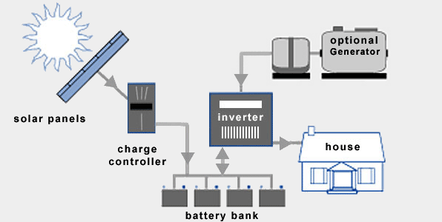

* + 1. ***Solar Panels:*** The system starts with solar panels, which are installed on a suitable location like a roof or ground. These panels capture sunlight and convert it into direct current (DC) electricity using photovoltaic (PV) cells.
    2. ***Charge Controller:*** The DC electricity generated by the solar panels is then sent to a charge controller. The charge controller's main function is to regulate the charging of batteries and prevent overcharging, which can damage the batteries.
    3. ***Battery Bank:*** Energy generated by the solar panels is stored in a battery bank. These batteries store excess energy produced during sunny periods so that it can be used when the sun is not shining, such as during nighttime or cloudy days.
    4. ***Inverter:*** Energy stored in batteries is in the form of DC electricity. Most household appliances and electronics require alternating current (AC) electricity to function. An inverter is used to convert the stored DC electricity into usable AC electricity.
    5. ***AC Loads:*** The AC electricity produced by the inverter can now be used to power various appliances, lights, and electronics in your off-grid location.
    6. ***Backup Generator (Optional):*** In regions with limited sunlight or high energy demands, an optional backup generator might be integrated into the system. This generator can provide electricity during prolonged periods of low solar output or when the battery bank is depleted.

**Advantages:**

1. ***Grid Independence:*** These systems provide complete independence from the utility grid, making them ideal for remote locations or areas with unreliable grid access.

2. ***Energy Backup:*** With a battery bank for energy storage, off-grid systems can provide consistent electricity even during cloudy days or nighttime.

3. ***Environmental Benefits:*** Off-grid systems use clean and renewable solar energy, reducing reliance on fossil fuels and lowering carbon emissions.

**Disadvantages:**

***1. Higher Initial Costs:*** Setting up an off-grid system involves purchasing solar panels, batteries, inverters, and other components, which can be expensive upfront.

***2. Limited Energy Storage:*** Capacity of battery banks determines how much energy can be stored for cloudy days or at night. Oversizing the battery bank increases costs.

***3. Maintenance:*** Batteries in off-grid systems require regular maintenance, including monitoring water levels (for lead-acid batteries) and occasional replacements.

***5. Space Requirements:*** To generate enough energy, you might need a larger number of solar panels, requiring adequate space for installation.

***6. Backup Generation (Optional):*** In some cases, an off-grid system might need backup generators, which can introduce additional maintenance and fuel costs.

**RAIN WATER HARVESTING**

Rainwater harvesting is the practice of collecting, storing, and using rainwater for various purposes, such as irrigation, domestic use, and groundwater recharge. This sustainable water management technique helps reduce reliance on traditional water sources and conserves freshwater resources.

* To supplement the ever growing shortage of protected, pure and safe water supply for human consumption, rainwater is an ideal source which can be conserved and used in a useful manner by the people.
* Two major systems that are ideal for urban and semi-urban developed areas are:

1. Artificial ground water recharge and
2. Roof top rainwater harvesting

**a) Artificial ground water recharge:**

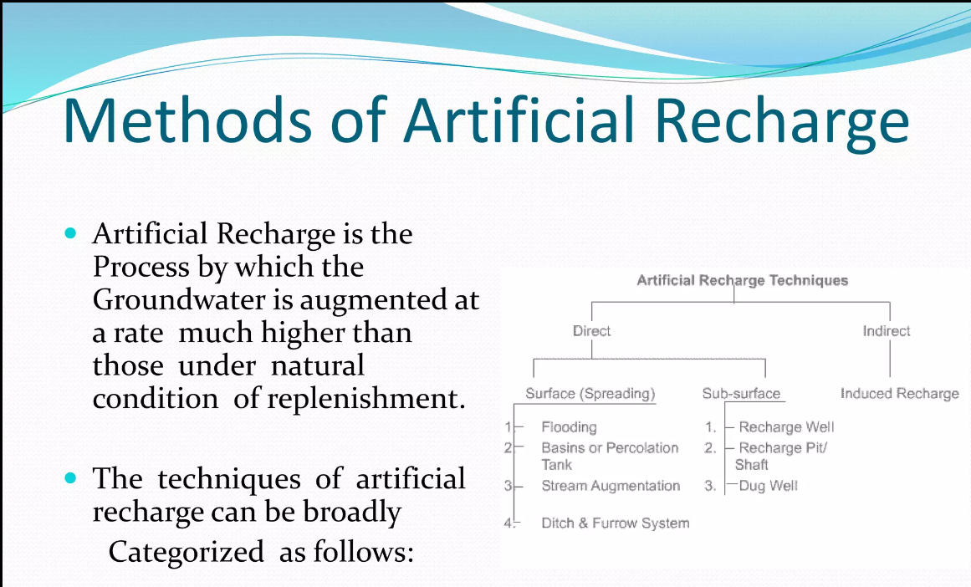

1. **Roof Rain Water Harvesting:**

Roof rainwater harvesting is a common and effective method of collecting rainwater from rooftops and storing it for various uses.

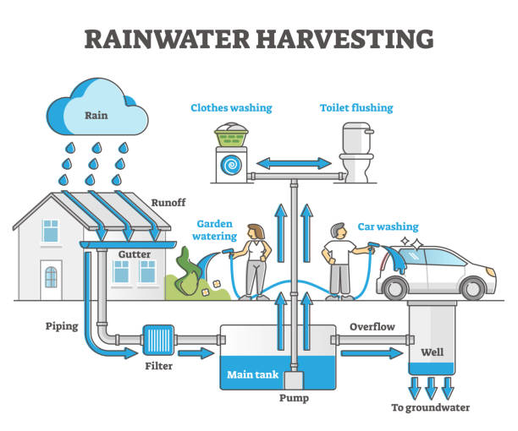

***1. Catchment Area:*** The first step is to identify the catchment area, which is the surface where rainwater will be collected. In this case, it's the rooftop of a building. The catchment area's size and design determine how much rainwater can be harvested.

***2. Conveyance System:*** Gutters and downspouts are installed along the edges of the rooftop to channel rainwater from the catchment area to the storage system. The gutters collect the rainwater and direct it towards the downspouts.

***3. First-Flush Diverter (Optional):*** In some systems, a first-flush diverter is installed in the downspout. This device ensures that the initial runoff, which might contain debris and contaminants from the roof, is diverted away before allowing clean rainwater to enter the storage system.

***4. Filtration:*** A filtration mechanism, such as mesh screens or sediment filters, is usually installed along the conveyance path or before the water enters the storage tank. This filtration removes leaves, debris, and other particles from the rainwater. Types of Filters are Sand Filter, Charcoal filter, PVC pipe filter and Sponge filter.

***5. Storage Tanks:*** The filtered rainwater is collected in storage tanks or cisterns. These tanks can be made of various materials, including plastic, concrete, or metal. The tanks can be located above ground or buried underground, depending on available space and design preferences.

***6. Overflow System:*** To prevent overflow and flooding, an overflow system is installed. Excess rainwater that cannot be stored is diverted away from the storage tanks and led to a suitable drainage area.

***7. Distribution System:*** When the stored rainwater is to be used, it can be pumped or gravity-fed from the storage tank to its intended end uses. This might include irrigation, toilet flushing, laundry, or even treated for potable use, depending on the system's design and water quality.

**Advantages of Rainwater Harvesting:**

1. ***Conservation of Freshwater:*** Rainwater harvesting reduces the demand for traditional water sources like rivers and groundwater.

2. ***Self-Sufficiency:*** It promotes self-sufficiency in water supply, particularly in areas with unreliable or limited access to municipal water.

3. ***Reduced Runoff and Flooding:*** Collecting rainwater reduces stormwater runoff, which can contribute to urban flooding and erosion.

4. ***Cost Savings:*** Using harvested rainwater for non-potable purposes like irrigation or toilet flushing can lead to reduced water bills.

5. ***Environmentally Friendly:*** Rainwater harvesting helps reduce the strain on local water bodies and ecosystems, supporting biodiversity.

6. ***Groundwater Recharge:*** Properly managed rainwater harvesting systems can contribute to groundwater recharge by allowing rainwater to infiltrate the soil and replenish aquifers.

**Challenges and Considerations:**

1. ***Rainfall Patterns:*** The effectiveness of rainwater harvesting depends on the local climate and the frequency and amount of rainfall.

2. ***Initial Costs:*** Installing rainwater harvesting systems can involve initial expenses for components such as storage tanks, filtration systems, and plumbing.

3. ***Maintenance:*** Regular maintenance is necessary to clean filters, check for leaks, and ensure the stored rainwater remains safe for its intended uses.

4. ***Water Quality:*** Proper filtration and treatment are essential to ensure the harvested rainwater is safe for consumption or other uses.

5. ***Regulations:*** Some regions have regulations governing the collection and use of rainwater, especially for potable purposes.

**Harvesting in regular rainfall areas:**

* In areas having rainfall over a large period in a year, for example in hilly areas, coastal regions, etc constant and regular rainfall can be usefully harvested and stored in suitable water tanks.
* Water shall be collected through roof gutters and down take pipes. Provision should be made to divert the 1st rainfall after a dry spell so that ant dust, soot and leaves, etc, are drained away before the water is collected into the water tank.
* The capacity of the water tank should be enough for storing water required for consumption between two dry spells.
* The water tank shall be located in a well protected area and shall not be exposed to any hazards of water contamination from any other sources.
* The water shall be chlorinated using chlorine tablets or solution to maintain a residual chlorine of approximately 1 mg/l. The tank shall have an overflow leading to natural water courses or to any additional tanks.

**Harvesting in limited rainfall areas:**

* In areas with the rainfall limited during the monsoon period (usually from 15-90 days), roof top rainwater can be stored and used for non-potable purposes, after proper treatment, in the premises itself as mentioned above; excess water, if any, is best used for recharging the ground water.
* For individual properties and plots the roof top rainwater can be diverted to underground or above ground water storage tank(s), pretreated, stored and used for non-potable purposes.
* Excess water, if any, may be discharged to existing open or abandoned tube wells. In a well-planned building complex, a system should be laid out so that the runoff is collected in underground or above ground water storage tank(s), pretreated, stored, and used for non-potable purposes.
* Excess water, if any, shall be discharged in bore-wells as per designs specified by the Central Ground Water Board, Government of India.

**Rainwater harvesting for plotted/group housing developments**

* The rainwater harvesting methods adopted for plotted and group housing are through collection of rooftop rainwater and surface runoff harvesting.
* A network of storm water drains in the entire residential area is used for harvesting rooftop rainwater and surface runoff.
* Appropriate number of recharge wells measuring 1 m × 1 m × 2 m may be constructed in the storm water drain for facilitating groundwater recharge.
* The quality of runoff, which passes through the borewell installed inside the recharge well, is ensured through a filter bed of pebbles.

**CLIMATE AND ENERGY:**

The relationship between climate and energy is complex and important.

1. ***Fossil Fuels and Greenhouse Gases:*** Traditional energy sources like coal, oil, and natural gas involve the burning of fossil fuels. This process releases carbon dioxide (CO2) and other greenhouse gases into the atmosphere, which contribute to global warming and climate change. The increased levels of these gases in the atmosphere trap more heat, causing the Earth's average temperature to rise, a phenomenon known as the greenhouse effect.

2. ***Renewable Energy and Lower Emissions:*** Renewable energy sources such as wind, solar, hydro, and geothermal do not release greenhouse gases (or very minimal) during operation, making them a crucial part of efforts to mitigate climate change. Transitioning from fossil fuels to renewable energy is an important strategy for reducing greenhouse gas emissions and limiting global warming.

3. ***Climate Impact on Energy:*** On the flip side, climate can affect energy production and demand. For instance, changes in wind patterns can impact wind energy production, droughts can reduce availability of water for hydropower and cooling thermal power plants, and increasing temperatures can raise energy demand for cooling.

4. ***Energy Efficiency:*** Improving energy efficiency – that is, getting more services out of each unit of energy consumed – can also have a significant impact on climate change mitigation. Greater efficiency reduces the amount of energy needed and thus the amount of fossil fuels burned and greenhouse gases emitted.

5. ***Energy Policy and Climate Policy:*** Energy policy has significant implications for climate change. Decisions about what types of energy to invest in, how to regulate energy production and consumption, and how to incentivize energy-saving measures can all influence the amount of greenhouse gases that a country emits. Therefore, energy policy is a key part of any comprehensive approach to addressing climate change.

**MACRO AND MICRO CLIMATE:**

* The climate of the earth consists of a series of interlinked physical systems powered by the sun. In the built environment we are generally concerned with local climate systems in particular
* ***Macro – climate: The climate of a larger area such as a region or a country***
* ***Micro- Climate: the variations in localized climate around a building***
* The macro and micro climate has a very important effect on both the energy performance and environmental performance of buildings, both in the heating season and summer.
* The site and design of a building can have a profound effect upon the interaction between a building and its environment.
* The building site affects exposure to the prevailing wind, the solar radiation the building receives, pollution levels, temperatures and rain penetration.

***Site and Micro Climate:***

* The orientation of the building affects solar gains and exposure to the prevailing wind(Ventilation).
* The location of neighboring trees and buildings affects the solar gains(shading) and wind patterns.
* Neighboring trees and buildings also protect the building from driving rain.

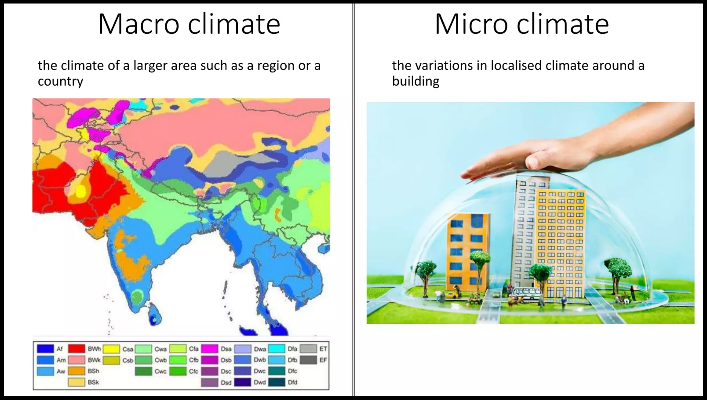

**MACRO CLIMATE:**

* The macro climate around a building cannot be affected by any design changes, however the building design can be developed with a knowledge of the macro climate in which the building is located
* General climatic data give an idea of the local climatic severity:
  + Seasonal accumulated temperature difference (degree day) are a measure of the outside air temperature, though do not account for available solar
  + Typical wind speeds and direction
  + Annual totals of global horizontal solar radiation
  + The driving rain Index (DRI) relates to the amount of moisture contained in exposed surfaces and will affect thermal conductivity of external surfaces
* This metereological data gives a general impression of the climate at the site of a building and the building design can be planned accordingly.
* However the building itself and surrounding geography will affect the local climate.

**Micro Climate**

* The site of a building may have a many micro climates caused by the presence of hills valleys, slopes streams and other buildings

***Micro Climate – Effect of local terrain and Buildings***

* Surrounding slopes have important effects on air movement, especially at the bottom of a hollow. In hollows air warmed by the rises upwards due to buoyancy effects(anabatic flow), to be replaced by cooler air drifting down the slope(katabatic flow).
* The result is that valley floors are significantly colder than locations part way up the slope..
* The most favorable location in a valley is known as thermal belt, lying just above the level to which pools of cold air build up, but below the height at which exposure to wind increases.
* Buildings themselves create further micro- climates by shading the ground, changing wind flow patterns.
* One example of how buildings affect the local climate is the heat island effect in large cities where the average temperature is higher than the surrounding area
* Solar energy absorbed and re-emitted from building surfaces, pavements roads etc. creates a warming effect on the surrounding air
* Also the large quantities of buildings break up the wind flow, reducing wind speeds and causing the warm air to remain stagnant in the city. This also causes increased pollution as well as temperatures.
* The presence of local high rise buildings can degrade the local climate as wind speed at ground level can be significantly increased, while extensive shadows block access to sunlight for long periods, increasing space heating costs in surrounding buildings.

**IMPROVING MICRO CLIMATE THROUGH DESIGN**

* The aim of enhancing micro climate around buildings:
* Reduce costs of winter heating
* Maximize outdoor comfort in summer and winter
* Improve durability of building material (reduced rain penetration)
* Provide a better visual environment in spaces around buildings
* Encourage growth of plants
* Discourage growth of mosses and algae
* Facilitate open air drying of clothes
* Enhancing the micro climate around a building include:

**SOLAR ACCESS:**

* Allow maximum day light and maximum solar radiation into space and buildings;
* shade space and window from prolonged exposure to summer sun
* Protect space and windows from glare

**Wind Protection:**

* Protect space and buildings from prevailing winds and cold
* Prevent buildings and terrain features from generating turbulence
* Protect spaces and buildings from driving rain and snow
* Protect space and buildings from katabatic flows, while retaining enough air movement to disperse pollutants

**FEATURES:**

* Provide thermal mass on moderate extreme temperatures
* Use vegetation for sun shading and wind protection(transpiration helps moderate high temperatures)
* Provide surfaces that drain readily
* Provide water for cooling be evaporation (Pools and fountains)

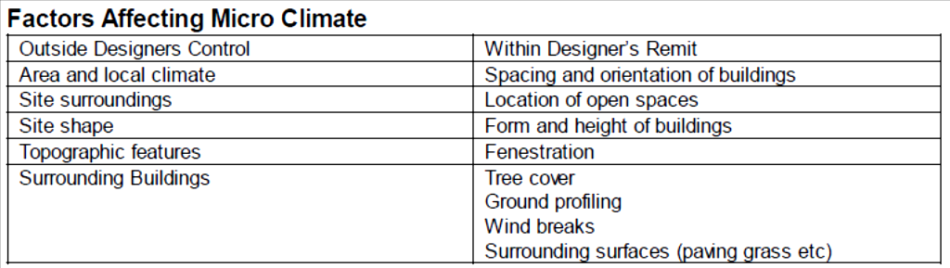

Two main possiblities for influencing micro climate are solar access and wind control:

**Solar access:**

* Solar access to a site is often a case for minimizing solar overheating in summer while maximizing solar access during the winter
* Buildings with a heating requirement should be orientated north south with maximum glazing on the south face.
* Deciduous trees offer an excellent means of site shading, with shading being reduced in winter when the trees lose their leaves
* Grass planted outside a building will reduce the ground reflected solar
* Use of courtyards and water can also moderate the effects of high temperature on summer.

**Wind control:**

* The form of the building can have a great effect on the impact of the wind:
  + Avoidance of the funnel like gaps between buildings
  + Avoidance of flat roofed buildings and cubical forms
  + Avoid abrupt changes in buildings heights
  + Orientate long axis of the building parallel to the direction of the wind
  + Use pitched rather than flat roofs and stepped forms for higher buildings
* Coniferous trees and fencing and other landscape features such as mounds of earth and hedges can also reduce the impact of wind and driving rain on the building structure

**Enhanced Micro climate and energy saving**

* Increased external air temperature leading to reduced space heating reduction
* Increase solar access to site, wind protection, external thermal mass, quick drying surfaces.
* Reduced air change rate, internal air movement and decreased external surface connective heat transfer; reduced pressure driven ventilation by wind protection.
* Reduced moisture effects on fabric (wall); less wetting of fabric and energy loss due to evaporation form wet surfaces by protecting from driving rain and providing adequate surface drainage

**INDIAN EXAMPLES:**

India is a vast and diverse country with varying macro and micro climates due to its geographical features, elevation, and regional influences. Here are some examples of macro and micro climates in India:

**Macro Climates:**

1. ***Tropical Climate (Macro):*** Large parts of India experience a tropical climate with high temperatures and distinct wet and dry seasons. The southern regions, such as Kerala and Tamil Nadu, have a tropical monsoon climate, while northern regions like Rajasthan have a tropical desert climate.

2. ***Himalayan Climate (Macro):*** The Himalayan region in the northern part of India experiences a mountain climate. It includes various zones based on elevation, ranging from temperate to alpine and tundra climates. For instance, Shimla in Himachal Pradesh has a temperate climate, while higher elevations have an alpine climate.

3. ***Coastal Climate (Macro):*** Coastal regions, like those along the Arabian Sea and the Bay of Bengal, have a maritime climate characterized by moderate temperatures and high humidity. Cities like Mumbai and Chennai experience this type of climate.

4. ***Semi-Arid and Arid Climate (Macro):*** Northwestern India, including parts of Rajasthan and Gujarat, has a semi-arid and arid climate characterized by low rainfall and high temperatures.

**Micro Climates:**

1. ***Urban Heat Island (Micro):*** Major cities like Delhi and Mumbai often exhibit urban heat island effects. Due to increased construction and human activity, these areas experience higher temperatures compared to their surrounding rural areas.

2. ***Forest Microclimate (Micro):*** Within dense forests, there can be microclimates due to the shading and cooling effect of trees. These areas might have lower temperatures and higher humidity compared to nearby open areas.

3. ***Mountain Valley Microclimate (Micro):*** In the Himalayan valleys, there can be significant temperature variations between the valley floor and the surrounding slopes due to differences in solar radiation and air movement.

4. ***Coastal Microclimate (Micro):*** Along coastal areas, localized breezes and humidity levels can create microclimates. For instance, coastal villages might experience milder temperatures due to the cooling effect of the sea.

5. ***Rural Agricultural Microclimate (Micro):*** Rural areas with extensive agricultural activities might have microclimates influenced by factors like irrigation, crop cover, and land use. These areas might experience cooler temperatures and higher humidity due to plant transpiration.

6. ***Urban Green Spaces (Micro):*** Parks, gardens, and green spaces within cities can create microclimates that are cooler and more humid than the surrounding built-up areas due to the presence of vegetation.

It's important to note that India's climate is highly diverse, and the examples provided are just a glimpse of the wide range of macro and micro climates found throughout the country. The complexity of India's geography leads to a rich tapestry of climatic conditions that contribute to its cultural and ecological diversity.